Integrating with SpecterX Google Drive Connector

Version & Data of Issue

Table of Contents
Google Drive Connector

Questions:

Google Drive Integration - Operator Manual - this documentation talks about two different approaches to the google drive integrations (Google Drive Menu Integration & Google Docs Button Integration).

- Menu integration looks like offering - what is the status of the Google Docs Button Integration?
- This all looks internal, what manuals t

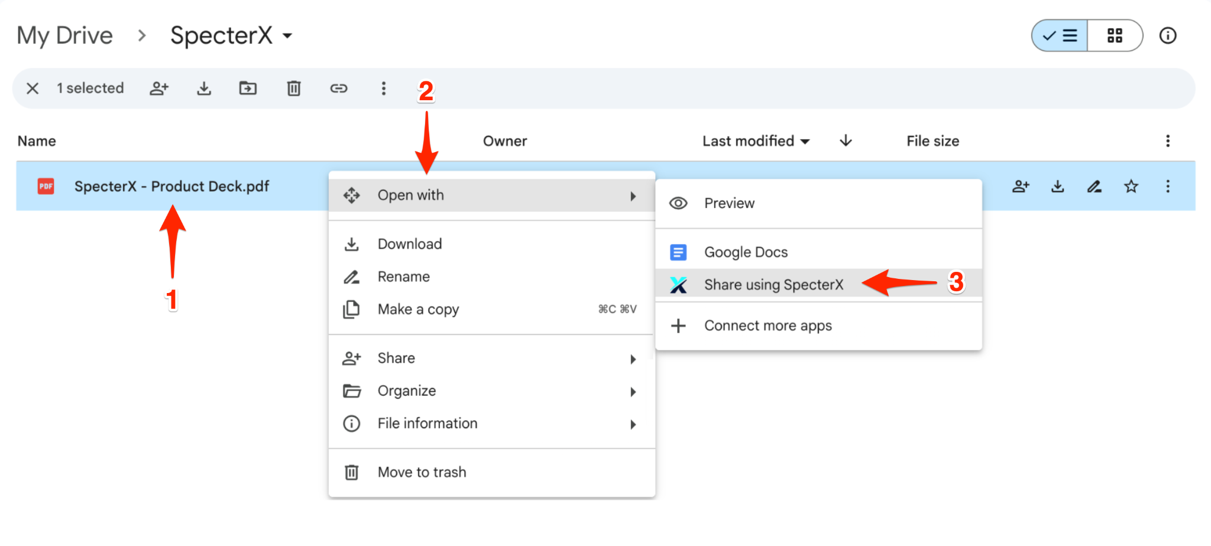
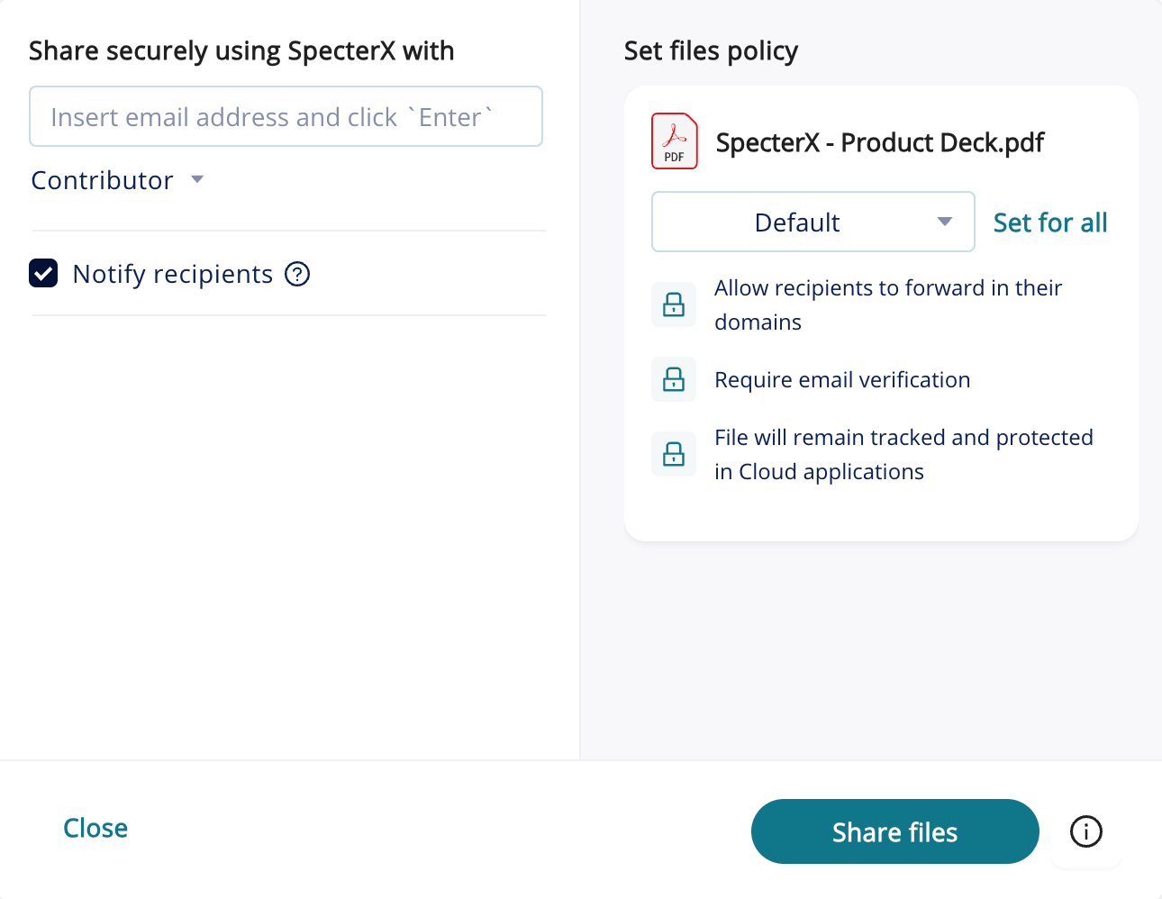

The Google Drive Connector supports the following file exports:
- Insert supported files

Questions:
- Can admin setup policy selection for Google Drive?
- Can admins setup transport rules for dynamic policy assignment within Google Drive?
- Do files shared through google connector automatically convert to microsoft files?
- Who becomes the data owner for exports from Google Drive?
- How do admins assign policies for SPX connectors?
- Are there any other parameters or limitations that I should know?
- Does the connector need to be enables for all users within the org/ does the whole org need to be licensed for SPX to use the Google Drive connector?
- File limits for sharing

